Geometry Model

Version 1.0

By: Maggie Eckhart
University of Michigan – Summer 2026
‘The Living Doc’

Big Question:
- Why does the Xenopus cell-free extract sometimes form compartments, and why does it sometimes not?
Hypothesis:
- Tubulin compartment formation reorganizes the cytoplasm into a mechanically ordered state that alters intracellular transport properties, leading to faster and/or more synchronized CDK1 signaling. The synchronization is then dependent on Tubulin compartment Geometry.
Experimental Observations:
- Sometimes compartments form, sometimes they don’t.
- Compartment shape changes throughout the sample’s lifetime.
- Sometimes the compartments divide, sometimes they combine.
- The size of the compartment varies over time.
- If left long enough, the compartments will start to crosslink with each other across the regions of no tubulin.
- Wave speed appears to be relatively consistent but then has a very steep drop off prior to arrest.
- Periodicity does the same.
- Wave data (non-compartment forming samples) last longer than compartment forming samples. More cdk1 waves.
- Parallel vector behavior is the most common across FRET /CFP and RFP channels.
- Sometimes, mechanical activity appears to spike prior to mitotic activity.
- Kymographs show parallel wave-speeds (nearly instantaneous) in compartment forming samples until arrest. This is also seen in the wave data (non-compartment forming samples) early on, but the wave speed does slow over time. For compartments, it seems to be a bit more steep of a drop off.
- ‘Highway’ paths of cytoplasm are formed in compartment samples where no tubulin appears to live.
- There is a lot of flow issues in compartment data (in terms of quantifying on ImageJ).
Variables:
- Diameter D(t), from ImageJ data Experimental
- Radius r, calculated from Diameter Calculated
- Growth rate G_{r}(Δr), calculated from change in radii Calculated
- Occupancy Fraction O_{f}(r, max_radii), calculated from current radii and max radii (assumed from ImageJ data) Calculated
- Dynamic Viscosity μ(H_{f}), calculated from baseline viscosity, crowding constant and Occupancy fraction Calculated
- Effective Diffusion D_{eff}(μ), calculated from baseline diffusion and dynamic viscosity Calculated
- Local Flow U_{local}(μ), calculated from the pressure gradient and dynamic viscosity, inclusion of boundary condition given by growth rate Calculated and Boundary and Modeled
- Transport coefficient T_{coe}(U_{local}, D_{eff}), calculated from local flow, baseline flow, baseline diffusion and effective diffusion Calculated and Modeled
- Delta Relative Phase Delay Δ Rel_{phaselag}(T_{coe}), calculated from the transport coefficient Calculated and Modeled and Comparable
Workflow, from experimental data to validation:
Experimental Data, Microscope images
Record frame, corresponding time (depending on timestep) and measure the diameter of the compartment in pixels. Convert pixel/min 2.6 μm/pixel. Create a plot on Excel and take linear best fit line. This is our POLYRATE calculation.
Identify Compartment of Interest

Model Version 1.0: Code Workflow

Polyrate (cycle & time dependent)
Delta radii (dr) = radius – radius [-1]
Radius = diameter /2
Diameter= polyrate

Occupancy Fraction = 1- (radii / max radii) max radii = (largest radii recorded experimentally + 20 μm)
Growth rate = dr / dt

Boundary Condition: no-slip boundary condition, low Reynolds number: the velocity of the flow must be at least the velocity of the growing cluster or else flow ceases. We know flow continues because we see cdk1 waves which propagate via cytoplasm. THEREFORE: growth rate < baseline flow, local flow = growth rate. IF growth rate < baseline flow then, local flow = baseline flow.
Dynamic Viscosity = μ₀e^{-k* (occupancy fraction)}

Effective Diffusion = D₀*μ₀/ μ
Local Flow = C*(∇p / μ ) + (baseline flow * background transport)

Transport Coefficient= (D_{e} / D₀) * (local flow/baseline flow)

Relative Phase Delay = 1 / Transport Coefficient

Equations & Justifications:
- Polyrate: This is derived by recording the frame and corresponding time (time step dependent) along with the diameter change in pixel and creating a linear line of best fit. In later models this can be modified to a polynomial line of best fit for more accurate growth tracking. The polyrate is then multiplied by the pixel per micron scaling number of 2.6.
Equation: POLYRATE = (mx + b) * 2.6
Units: μm
- Diameter: Since the polyrate is essentially a linear equation for diameter given some time, Diameter can be set equal to polyrate.
Equation: DIAMETER = POLYRATE
Units: μm
- Radius: this equation is self-explanatory.
Equation: RADIUS = DIAMETER / 2
Units: μm
- Δ Radii: This is self-explanatory .
Equation: Δradii = Radii[i] – Radii[i-1]
Units: μm
- Growth Rate: This is the rate of the tubulin clusters growing. This value is also the velocity on the cluster at a given time.
Equation: G_{rate} = Δr / Δt
Units: μm / min
- Compartment Occupancy Fraction: This equation is assumed in Version 1 of this model. It’s purpose is to calculate how large the compartment is relative to its maximum. This fraction may not exceed 1 in the version 1(though later, if a model would like to introduce a crosslinking factor amongst the clusters this will be modified). This is measured by taking the current radii of the cluster and dividing it by its maximum. Later we can use a volume calculation to align more with what other models do. This calculation will have downstream effects on viscosity. Theoretically, the larger the compartment, the less free flowing tubulin will sit in these highway regions effecting viscosity. It might also be interesting to look at the stress and pressure changes in latter models of the compartment formation.
Equation: O_{fraction}= (radii/ max radii)
Units: unitless
- Dynamic Viscosity: This equation is also currently assumed in Version 1 of this model. The equation is taken from basic fluid mechanics where the baseline viscosity is multiplied and exponential value of the occupancy fraction. The reasoning here is that the viscosity will change along the highway as more tubulin polymerize into the clusters. The baseline viscosity and the crowding constant, k, put as 1 to minimize noise. The exponential is taken as – because as the occupancy fraction increases, viscosity along said highway should decrease.
Equation: μ = μ₀e^{-kɸ}
Units: Pa * min
- Effective Diffusion: The effective diffusion parameter should be based on the current diffusion and the viscosity. This equation was derived from basic fluid mechanics and the relation between diffusion and viscosity (inverse). The dynamic viscosity is normalized to it’s baseline.
Equation: D_{eff} = ( μ₀ / μ ) * D_{0.}
Units: μm² / min
- Local Flow: Local flow was derived using a constitutive relationship motivated by low-Reynolds-number transport. Lower local viscosity produces higher local flow. A lower boundary is imposed by the compartment growth velocity. C is a proportionality constant to ensure that the parameter is in the correct units.
Equation: U_{local} = C(∇p / μ ) + (U_{baseline} * Transport_{background})
Units: μm / min
- Transport Coefficient: This value is based on the relationship between diffusion and flow to determine transport. This equation is also a simplification unique to Version 1 of the model. The diffusion and flow are normalized to the baselines.
Equation: T_{coe} = (D_{e} / D₀) * (U_{local} /U_{baseline})
Units: unitless
- Relative Phase Delay: This equation was derived based on the inverse relationship between transport and how much the cdk1 activity could lag relative to the mechanical. Since if the transport increases, the lag between the large mechanical activity spike and the mitotic activity spike would decrease since information is being passed ‘quicker’.
Equation: ΔP_{lag} = 1 / T_{coe}
Units: unitless
Assumptions:
- Baseline flow = 1.0
- A background transport variant that accounts for ATP consumption, microtubule density, cytoplasmic reorganization, ect.
background_transport = 1.0 + 0.15*np.sin(2*np.pi*i/(6*T))
- Crowding constant, k = 1.0
- Baseline Diffusion = 1.0
- Pressure Gradient = 1.0
- Treating the cytoplasm and a Low Reynolds Number, this implies that the fluid is dominated by viscosity and that there is little to no inertia no momentum. The justification for this is that the flow appears to be laminar after the initial compartment formation. This can be validated later when we get viscosity, density and linear size data.
- Assuming that the mitotic activity is lagging relative to the mechanical activity.
- Dynamic viscosity calc in model 2, this could be improved on.
- Occupancy fraction calc in model 2, this could be improved on.
- Constant Periodicity, T = 60.
Model Validation:
Compartments:
Model Experimental
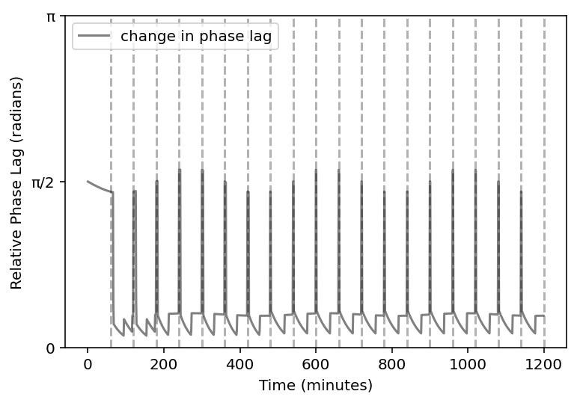
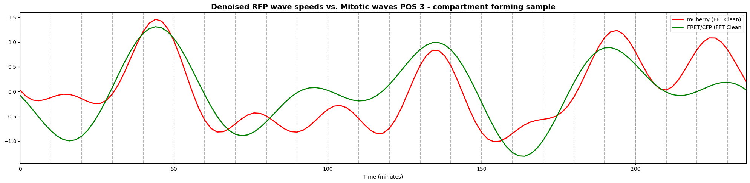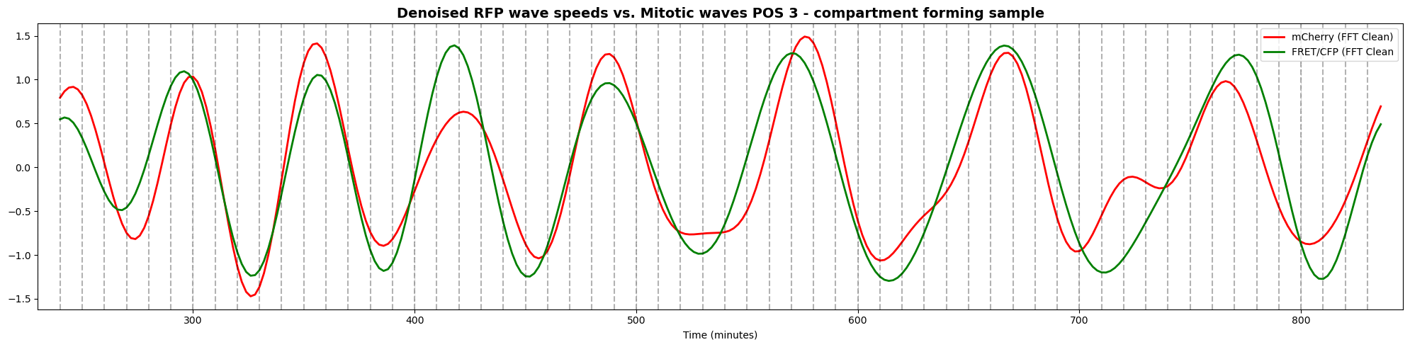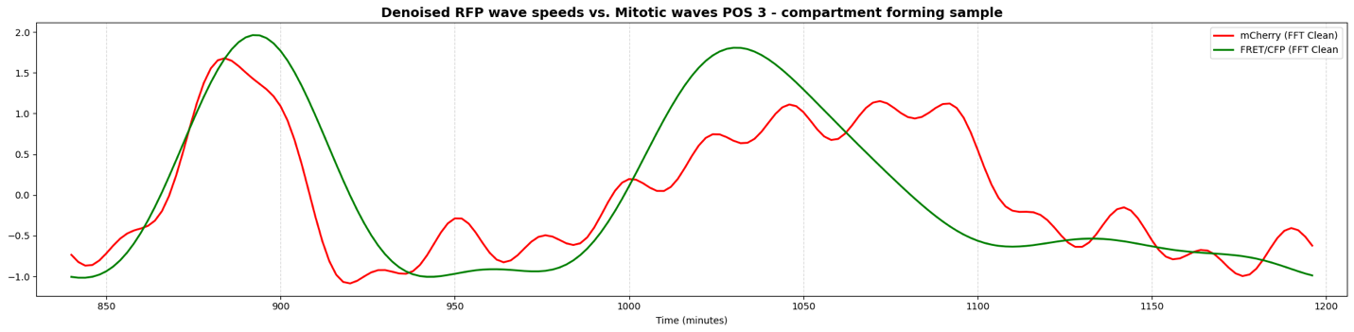
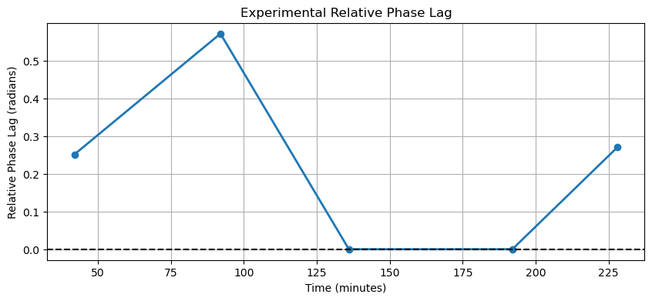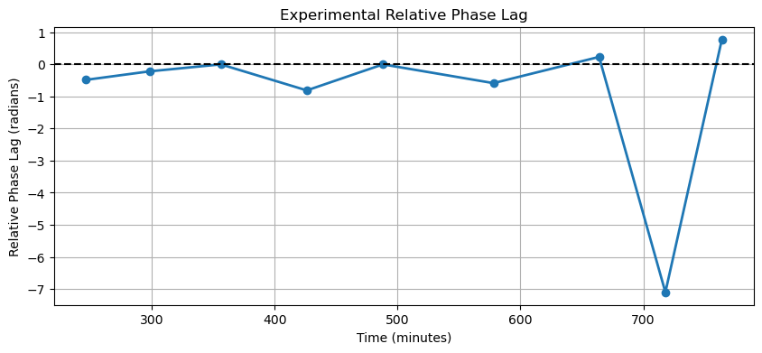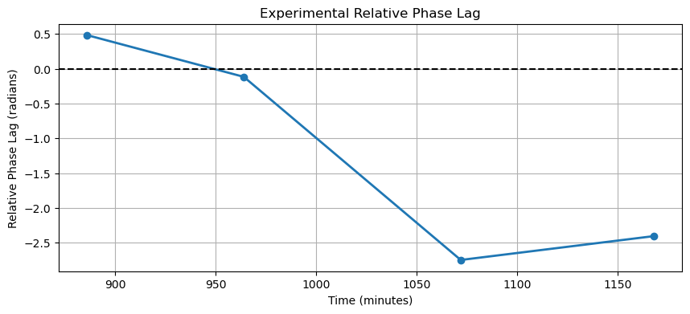
Notes: the compartment forming samples seem to follow a closely inphase relationship. With outliers only occurring when the mechanical activity is variable. The experimental results appear to align with the model results, of course, with more variability. Something interesting is that the mitotic activity begins to lead in the middle of the samples life where mechanical dominates during the other times. We also see the most oscillations per time in the middle chunk of the sample’s life. In order to corroborate these results, we need more data (will analyze more positions later!).
No compartment, control:
Model Experimental
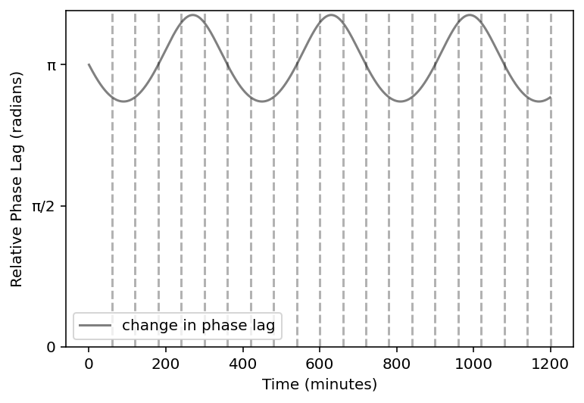
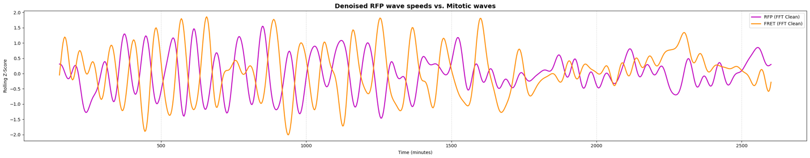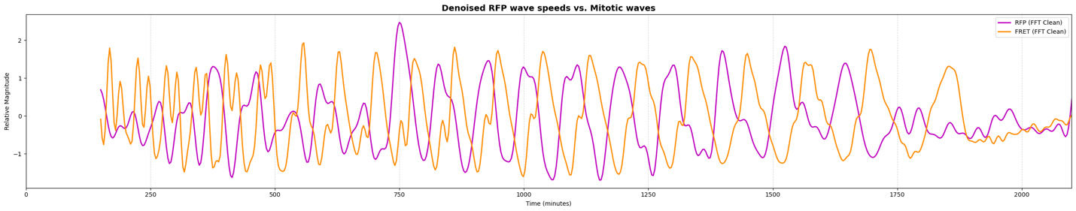
Notes: there is a clear anti-phase relationship here in the non-compartment forming samples. Experimental results look like the model’s results. In order to corroborate these results, we need more data.
Other cool questions:
- Does compartment size affect the transport
- FULL ENTROPY AND THERMO MODEL (would be hella sick, free-energy too!)
- Active matter modeling
- Phase-separation, not theory but now test and model
- Multi-compartment wide interactions (do they interact?)
REMEMBER, note to self:
- Trying to not say why compartments form BUT what are the physical ramifications of compartment formation.

